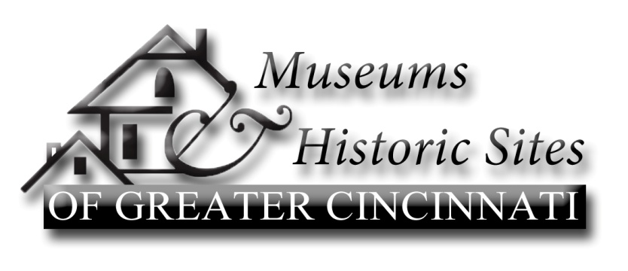
Museums & Historic Sites of Greater Cincinnati, founded in 1992, promotes the historic property museums, libraries, and historical societies in the Greater Cincinnati area. The mission of the consortium is to engage in tourism related activities, educational programming, and other activities which encourage an appreciation of the Ohio River Valley and its history.
Chairperson: Terrie Puckett
Vice Chairperson: Aashi Mital
Secretary: Pat Young
Treasurer: Ed Creighton
Meeting minutes for September 13, 2015, Lloyd Library
Attendees: Becky Johnson and Cora Arney, Delhi Historical Society; Penny Huber, Mt. Healthy Historical Society; Ashi Mital, Pivotal Solutions; Anna Heran, Lloyd Library and Museum; Patricia Young, Christian Waldschmidt Homestead and Civil War Museum; Bill Dichtl, Heritage Village Museum; Craig Neimi, Cincinnati Observatory; Kathy Creighton, Butler County Historical Society ; Ed Creighton, Oxford Museum Association/Riley Township Historical Society/Gov. Bebb/Heritage Program at the Cincinnati Museum Center; Kelsey Sturgill, MetroParks of Butler County; Cassandra Willoughby, Oxford Museum Association; Steve Preston, Heritage Village Museum; Patrick Thibodeaux, Lloyd Library; and Chairman, Terri Puckett, Grailville.
Terri opened the meeting at 10:00am, giving brief introductions. We welcomed Cora Arney an intern for Delhi Historical Society; Patrick Thibodeaux, an intern for Lloyd Library & Museum and Cassondra Willoughby, an intern for the Oxford Museum.
The minutes were approved.
- Ed gave the Treasurer’s report; the balance is $1,021.96.
- Old Business:
- Anna passed out boxes of the new “Rack Cards”. They are very attractive. Members will be distributing them to schools and groups. Kathy has already created a letter she is sending with the cards to schools and organizations in Butler County. The card will be put on the webstie and can be downloaded and printed. They will also be distributed to Homes School groups. Please send a message to the list requesting your cards.
- The Bylaws had been distributed during the past month. To clarify the number of meetings for the Consortium, Craig Niemi moved that the word “scheduled” be inserted in Article II, Section 4, so as to read, “There shall be a minimum of ten (10) scheduled meetings…”. Ashi seconded. The motion passed.
- The Nominating Committee, Terri Puckett and Ed Creighton, will announce the new slate of officers at the November meeting. Please let them know of your interest to serve.
- Discussion followed to have an evening meeting for October. A possible location could be the Washington Platform Restaurant. Watch for a message confirming the location for October 5, at 6:30.
- Announcements
- Grailville is looking for an assistant.
- March 19, 2016; Regional Local History Alliance.
- National History Day; please check the website
- Ohio History Alliance Conference in October.
- Heritage Village – “Echoes of the Past”, Oct 2 & 3; “Haunted Village”, 3 Fridays and Saturdays and “Holly Days” in December.
- Lloyd Library – October 10, opening of the “Historic Forest Lands”. In January, hosting “Trees in Trouble”.
- Delhi is celebrating 200th Anniversary, 1816 to 2016 all year. Watch for events.
Business meeting adjourned.
The program was presented on the use of Past Perfect software for the inventory of museum content and creating an online searchable database for that inventory.

Next meeting Monday Oct 5 at 6:30pm.

Recording Secretary, Pat Young

