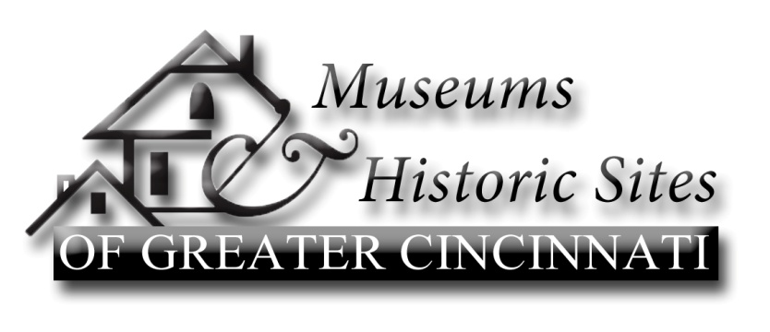
Museums & Historic Sites of Greater Cincinnati, founded in 1992, promotes the historic property museums, libraries, and historical societies in the Greater Cincinnati area. The mission of the consortium is to engage in tourism related activities, educational programming, and other activities which encourage an appreciation of the Ohio River Valley and its history.
Chairperson: Terrie Puckett
Vice Chairperson: Aashi Mital
Secretary: Pat Young
Treasurer: Ed Creighton

Meeting minutes for June 8, 2015, Butler County Historical Society
Attendees: Kathy Creighton, Butler County Historical Society; Richard Jones, Butler County Historical Society; Anna Heran, Lloyd Library and Museum; Marty McDonald, Dinsmore Homestead; Craig Niemi and Aashi Mital, Cincinnati Observatory; Nancy Yerian, Ohio History Service Corps/Freedom Center; Patricia Young, Christian Waldschmidt Homestead and Civil War Museum; Ed Creighton, Oxford Museum Association/Reily Township Historical Society/Governor Bebb/Heritage Program at Cincinnati Museum Center; Bill Dichtl and Steve Preston, Heritage Village Museum; Penny Huber, Mt Healthy Historical Society; Kelsey Sturgill, Butler County Metro Parks; Lee Hite, Cincinnati Triple Steam Museum; Milli Saermann and Lois Kingsley, Fairfield Historical Society & Elisha Morgan Heritage Gardens and Guest Speaker Greg Hand.
- Aashi opened the meeting giving brief introductions followed by a very short business meeting. Kathy Creighton described the current displays.
- The minutes were approved. Ed reported a balance on hand of $1,419.30.
- Aashi reminded us that next month we will revisit our committee structure and responsibilities. Members are encouraged to notify Terri or Aashi if they want to change.
- Aashi announced that due to vacation time, our educators will not be available for the July workshop. Therefore, the July 13 meeting will be at the regular time, 10am at Heritage Village.
- Announcements
  - Kathy reminded members to let her know if they are participating in the Arts and Crafts Fair in Oxford, June 13-14. The Smith Family Trust will again support the event. Craig discussed the concern that maybe the Arts & Crafts Fair should be held at other locations. The Smith Family Trust is willing to continue its support if it were to be held elsewhere. Butler County has the space and people are expecting it to be there. Thoughts were that attendance would drop if held at different locations. Grants from the Smith Family Trust are available to any non-profit educational event.
  - Chautauqua 2016 will be held in Butler County. Dates to be announced.
  - Oct 16, 17 & 18 ‘The Ohio River National Freedom Corridor Conference’ will be at the Eastgate Conference Center.
  - The Betts House is requesting items to use for a “Historic Cooking & Processing” Display.
  - The Observatory is celebrating 170 years of Astronomy in Cincinnati
  - The Midwest Museums Conference will be held in Cincinnati, July 19-22
  - National Docent Symposium in Cincinnati, Sept 17-20, 2015
  - Ohio Council for Social Studies Conference Oct 5-6, Columbus, Embassy Suites

Program Time: “Public Relations-Getting the Word Out” Greg Hand
Mr. Greg Hand worked in the Public Relations Office of the University of Cincinnati for 36 years. He has been a news reporter and editor and currently keeps a blog on “Weird Things in Cincinnati History”. Greg led us in a spirited conversation on communication and public relations. He gave each of us his booklet on “Publicity” and left us with these thoughts, “No one needs publicity” and “Publicity is a tool for telling your story”.
Next Meetings
July 13 10:00am, Heritage Village Museum – Retreat: committee planning
August 13 10:00am, Christian Waldschmidt Homestead, Rt 126, Camp Dennison
Recording Secretary
Patricia Young

