William Howard Taft NHS News Release

William Howard Taft NHS
2038 Auburn Avenue
Cincinnati, OH 45219

513-684-3262
www.nps.gov/wiho
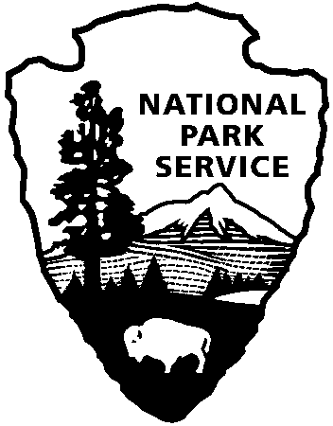
National Park Service
U.S. Department of the Interior

For Immediate Release: June 9, 2015
Contact: Reggie Murray
Phone/Email: (513) 684-3262, reggie_murray@nps.gov

Cincinnati’s National Park to Host Free Fourth of July Celebration:
An Ice Cream Social and Music Featuring
Live Performances by Greg Jowaisas and the Jazz Renaissance

On Saturday, July 4th from 1 to 4 p.m., the National Park Service at William Howard Taft National Historic Site will host our Annual Ice cream Social featuring live music and performances by folksinger and story teller, Greg Jowaisas, and live music by Jazz Renaissance. Our Annual Ice Cream Social and Fourth of July Celebration will be held on the grounds of Taft’s birthplace and boyhood home – the home of our nation’s 27th President and 10th Supreme Court Chief Justice.

Come join us at the park on the Fourth of July and enjoy free ice-cream and performances by two popular performers. Greg Jowaisas will perform late 19th and early 20th century folk music and storytelling. Thirty years ago Greg Jowaisas left his noble teaching profession to follow the call of the wild mountain banjo and made his infatuation with old-time music his full-time career. Jazz Renaissance is a seven-piece jazz group, formed in November, 2010. This jazz group plays modern jazz in many styles, including bop, swing, and Latin. They have played at many local venues and events including the Blue Wisp, Whiskey Bar, Juneteenth Celebration at Drake Park, and Black Family Reunion.
Events begin at the Taft Education Center, located at 2038 Auburn Avenue, one block south of the Christ Hospital. Free parking is available in front of the education center and at the parking lot on Southern Avenue. Please call (513) 684-3262 for accessibility information and assistance. A visit to the park includes a free ranger guided tour of William Howard Taft’s boyhood home, self-guided exhibits, and an introductory video on Taft’s life and career.
Tours will be conducted throughout the day from 8 a.m. to 4 p.m. All activities are free and reservations are not required. Driving directions, a map, calendar of events, and other useful information for William Howard Taft National Historic Site can be found at www.nps.gov/wiho. Plan your visit soon!

