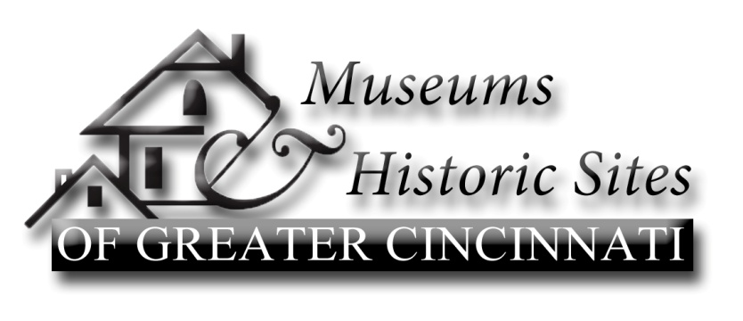
Museums & Historic Sites of Greater Cincinnati, founded in 1992, promotes the historic property museums, libraries, and historical societies in the Greater Cincinnati area. The mission of the consortium is to engage in tourism related activities, educational programming, and other activities which encourage an appreciation of the Ohio River Valley and its history.
Chairperson: Terrie Puckett
Vice Chairperson: Aashi Mital
Secretary: Pat Young
Treasurer: Ed Creighton
http://historicgreatercincinnati.org/ www.facebook.com/historicgreatercincinnati
MHS Listserve: www.freelists.org/list/mhsgreatercinci mhsgreatercinci@freelists.org

Meeting minutes for May 11, 2015, William Howard Taft National Historic Site
Attendees: Craig Niemi (Cincinnati Observatory Center), Bill Dichtl (Heritage Village Museum), Terri Puckett (Grailville), Hagit Carpi (Center for Holocaust & Humanity), Kerry Wood, Taft national Site), Joey Hansted (Morrow Area Historical Society), Kathryn Gibbons (Harriet Beecher Stowe House), Ed Creighton (Oxford Museum Association, and others), Kathy Creigthon (Butler County Historical Society), Marty McDonald (Dinesmore Homestead), Aashi Mital (MHS, Cincinnati Observatory Center), Nancy Yerian (Ohio History Service Corps), Penny Huber (Mt. Healthy Historical Society).
Guests: Andy Verhoff, History Fund Grant Manager & Historical Markers Coordinator, Ohio History Connection; David Merkowitz, Assistant Director, Ohio Humanities Council; Rob Colby, Program Officer, Ohio Humanities Council
- Introductions
- April Meeting minutes Approved. 1st Kathy Creighton, 2nd Penny Huber
- Treasurers Report. $1347.17 balance
  - GoDaddy webhosting charge due
  - A reminder about techsoup for non-profits. www.techsoup.org/
  - Reds Hall of Fame, Sign Museum and Clermont County Historical Society renewed
    - As a MHS member, reach out to other organizations re benefits of membership

- Old Business
  - July 13th Educators Expo
    - 12-2pm at the Heritage Village Museum
    - Flyer attached
    - Please help pass the word with teachers you work with
    - Contact Aashi Mital : aashimital@gmail.com
  - Oxford Museum Associations: 50th Arts & Fair June 13 & 14th
    - http://oxfordmuseumassociation.com/index.php?q=events/arts-and-crafts
    - MHS & MHS members are invited to participate again this year. Free for members to set up.
      - Set up 9am, Bring a table
      - Please pass event information along to you members
      - Discussion on whether MHS would like to participate every year and if MHS could help support paid advertising. Too late for additional radio/TV spots this year.
    - Contact Ed Creighton: ercmorgans@juno.com
- New Business
  - MHS Committee Structure
Marketing
Education
Special Events
Meetings
Nominating
By-Laws
    - Discussion on current MHS committees, their number, clarity of role, and ways to improve their effectiveness.
    - Are there too many overlapping? Should several be merged into one?
      - Should “Meetings” be part of Member Development?
      - Likewise Special Events & Education
        - Possible Subcommittees
    - Terri asked members to think about the committees and how they could be improved.
  - By-Laws Review.
    - Time for the biennial review of the MHS Bylaws.
      - Motion to proceed with Review.
        - 1st: Bill Dichtl, 2nd Aashi Mital
        - Kathy Creighton & Craig Niemi will meet to review the bylaws.
- Program” Grant Opportunities through Ohio History Connection and Ohio Humanities Council
  - David Merkowitz-Assistant Director Ohio Humanities Council Programs
  - Rob Coley-Program Officer, Ohio Cultural Heritage Tourism Grants
    - “Ohio First”
    - Seeking to link individual Sites stories to a larger statewide thematic experience
    - Engage the public (public facing) programs
    - Call or email David or Rob before submitting
    - How will you evaluate the program
    - Read the guidelines twice
  - Andy Verhoff-Ohio History Connection, Grant Manager averhoff@ohiohistory.org.
    - https://www.ohiohistory.org/preserve/local-history-office/history-fund
    - Bricks & Mortar, Organizational Development, and Programs & Collection
    - Grant Application help webinars 6/24, 7/14, 8/16
      - Don’t be overly ambitious
      - Don’t assume OHC will know your organization’s history and mission
Next Meetings:
June 8 Butler County Historical Society – PR program
July 13 12noon -2 pm, Heritage Village Museum – focus group discussions with educators

Respectfully submitted,
Craig Niemi

