**BUFFER ISSUE RESOLUTION DOCUMENT (BIRD)**

**ISSUE TITLE:** *AMI Touchstonefile ® Analog Buffer Models*

**REQUESTOR:**  *Walter Katz, Signal Integriity Software, Inc.*

**DATE SUBMITTED:** *{date you sent the document}*

**ANALYSIS PATH/DATA THAT LED TO SPECIFICATION:**

The IBIS 5.1 specification provides limited capability for describing the frequency-dependent behavior of a Serdes transmitter’s analog output driver or receiver’s analog input termination network. This makes it difficult to model a device’s insertion and return loss accurately, both of which are key factors in determining Inter-Symbol Interference (ISI) and overall signal quality. This BIRD assumes that the Tx analog output and Rx termination network are described using 4 port S-parameter data and that the .s4p data is developed in a manner consistent with the subcircuits and parameters defined below. The subcircuits used to instantiate the transmitter and receiver on-die S-parameters are shown on the following pages. These subcircuits are treated as standard templates that are used whenever the AMI parameters defined in this document are used in the .ami file. It is assumed that the value for the transmitter parameter Tx_V will be the I/O driver’s supply voltage in volts.

# Transmitter Driver Analog Circuit

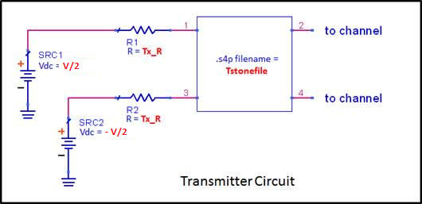

When logic level is 1, V=Tx_V. When logic level is 0, V=-Tx_V. The transition time between 1 and 0 in the two voltage sources is zero.

# Receiver Analog Termination Circuit

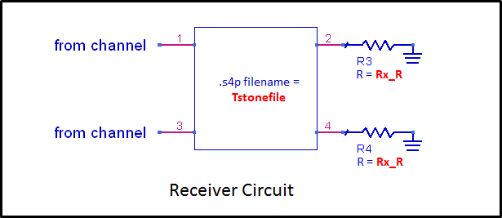

Voltage difference between ports 2 and 4 is the differential input to the Rx algorithmic model.

**ANY OTHER BACKGROUND INFORMATION:**

## Parameter DEFINITIONs

*Parameter:* **Tstonefile**

*Required:* No

*Descriptors*:

Usage: Info

Type: String

Format: Value, List, Corner

Default: None

Description:<String literal>

*Definition:* This parameter contains the name of the .S4P file to be used in the Analog Model Circuit. The .S4P can be measured at any reference impedance. See the Analog Circuit Definitions above for the pin order associated with the .S4P file.

*Examples:*

(Tstonefile (Usage Info)(Type String)(Corner “typ.s4p” “min.s4p” “max.s4p”))

*Parameter:* **Tx_V**

*Required:* Yes, if IBIS [Model] declarations of type Output and **Tstonfile** is defined.

*Descriptors*:

Usage: Info

Type: Float

Format: Value, List, Corner, Range, Increment, Step

Default: None

Description:<real literal>

*Definition:* This parameter defines the rail voltage of the I/O power supply in volts.

*Examples:*

(Tx_V (Usage Info)(Type Float)(Range 1. .5 1.))

*Parameter:* **Tx_R**

*Required:* No

*Descriptors*:

Usage: Info

Type: Float

Format: Value, List, Corner, Range, Increment, Step

Default: None

Description:<real literal>

*Definition:* This parameter is optional and defines the value of the Tx_R series resistor in ohms. It only applies to IBIS [Model] declarations of type Output. If not present in the .ami file, the value of Tx_R defaults to zero.

*Examples:*

(Tx_R (Usage Info)(Type Float)(Value 0.))

*Parameter:* **Rx_R**

*Required:* No

*Descriptors*:

Usage: Info

Type: Float

Format: Value, List, Corner, Range, Increment, Step

Default: None

Description:<real literal>

*Definition:* This parameter is optional and defines the value of Rx_R in ohms. It only applies to IBIS [Model] declarations of type Input. If not present in the .ami file, the value of Rx_R defaults to infinity, or a reasonable facsimile thereof.

*Examples:*

(Rx_R (Usage Info)(Type Float)(Value 1.e6))