Spiritual Culture for Harmonious Civilization
Citizens of Earth!
Unite in harmony for love, peace, justice, fraternity and happiness!

Global Harmony Association (GHA)
www.peacefromharmony.org
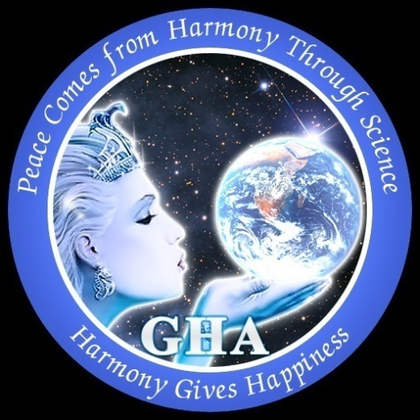

GHA Mission is:
To bring global peace from social harmony paving a conscious way for harmonious civilization via harmonious education in Global Peace Science within a deep social structure of four harmonious classes - SPHERONS employed in productive spheres: Sociosphere, Infosphere, Orgsphere and Technosphere
http://peacefromharmony.org/docs/global-peace-science-2016.pdf
GHA Video: Social Genome of Peace from Harmony -http://youtu.be/hbxY5lREOeA
---------------------------------------------------------------------------------------------------------------------

INTERNATIONAL WOMEN’S DAY – 8TH MARCH, 2016

GHA Message to Women of the World
Woman Mission in the 21st Century:
Global Peace through Harmony and Global Peace Science
http://peacefromharmony.org/docs/global-peace-science-2016.pdf

GHA congratulates all harmonious classes (SPHERONS’) women to wish you a happy life in peace from harmony, which can only be the result of your high moral mission of a balanced life dedicated to Global Peace via your priority in it

We all are the harmonious SPHERONS members and we must work to achieve gender equality, empower women more in politics, good governance and socio-economic projects.
GHA proud to celebrate International Women’s Dayon 8th March every year since we are deeply committed to promoting the role of women in peace building and transforming the world through peace from harmony & harmonious education.The 2016 theme for International Women’s Day is “Planet 50-50 by 2030: Step It Up for Gender Equality”
GHA’s Woman Mission in the 21st Century “Peace on Planet through Peace from harmony, Gender Equality & women empowerment by 2030.Women are the born peace makers & Peace Leaders for developing culture of peace & harmony in the families & in the society. Peace Education can initiate social changes and hence social development, by bringing about a change in attitude for gender equality, empowering women more in politics & good governance
GHA strongly believe that for a new era of peace, harmony, and sustainability to grow, there must be a rebalancing and harmonizing of the feminine power with the masculine. Women have been marginalized and suppressed for millennia and we are therefore keen on bringing forth the wisdom and power of the feminine and in supporting women in stepping forward in Peace leadership roles.
Global Peace Science: Victory of Peace over War in XXI century is having a Noble Peace Mission of ‘Vasudhaiva Kutumbkam’- World is One family through peace from harmony , Women dignity & empowerment for saving for the Earth planet & humanity in 21st century. http://peacefromharmony.org/?cat=en_c&key=585
An ideal woman can bring up children harmoniously, take care of her parents, inspire her husband to give up bad habits like excessive smoking / gambling / supporting anti-social activities etc and communicate with the world in a harmonious state of compassion and understanding of society, besides taking care of herself thru yoga and meditation .
While some women remain oppressed by male dominated society and adopt lifestyle which curtails their freedom like supporting veils or covering head , there are other women who In the name of women’s lib is seen to adopt bad life styles at the cost of ignorance of family ,children leading to split relations . In both the cases it is only women who have to change this as they are the ultimate sufferers. Therefore to have a peaceful world the women owns a key role in the world peace implementation .Women has a key role in the education of children in the spirit of Global Peace Science, which was first established in the Global Harmony!
Therefore to have a peaceful world the women owns a key role in the world peace implementation .Women has a key role in the education of children in the spirit of Global Peace Science, which was first established in the Global Harmony!
GHA congratulates Global women Peace Leaders and wishes you a happy life in peace from harmony noble mission of global peace!.
The GHA offers a bucket of flowers with PEACE & HARMONY!
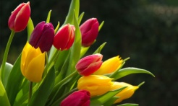
Happy Women’s Day!

Ayo Ayoola-Amale,  President, GHA Africa,  Vice president, GHA Int’l,  http://peacefromharmony.org/?cat=en_c&key=524 | Zaure Khizatolla,  GHA Vise-President and GHA-Kazakhstan:  http://peacefromharmony.org/?cat=en_c&key=466

Ramesh Kumar,  GHA Executive Director (CEO),  International Yoga Leader, India  http://peacefromharmony.org/?cat=en_c&key=658 | Dr. Subhash Chandra,  GHA Secretary General,  India  http://peacefromharmony.org/?cat=en_c&key=583

