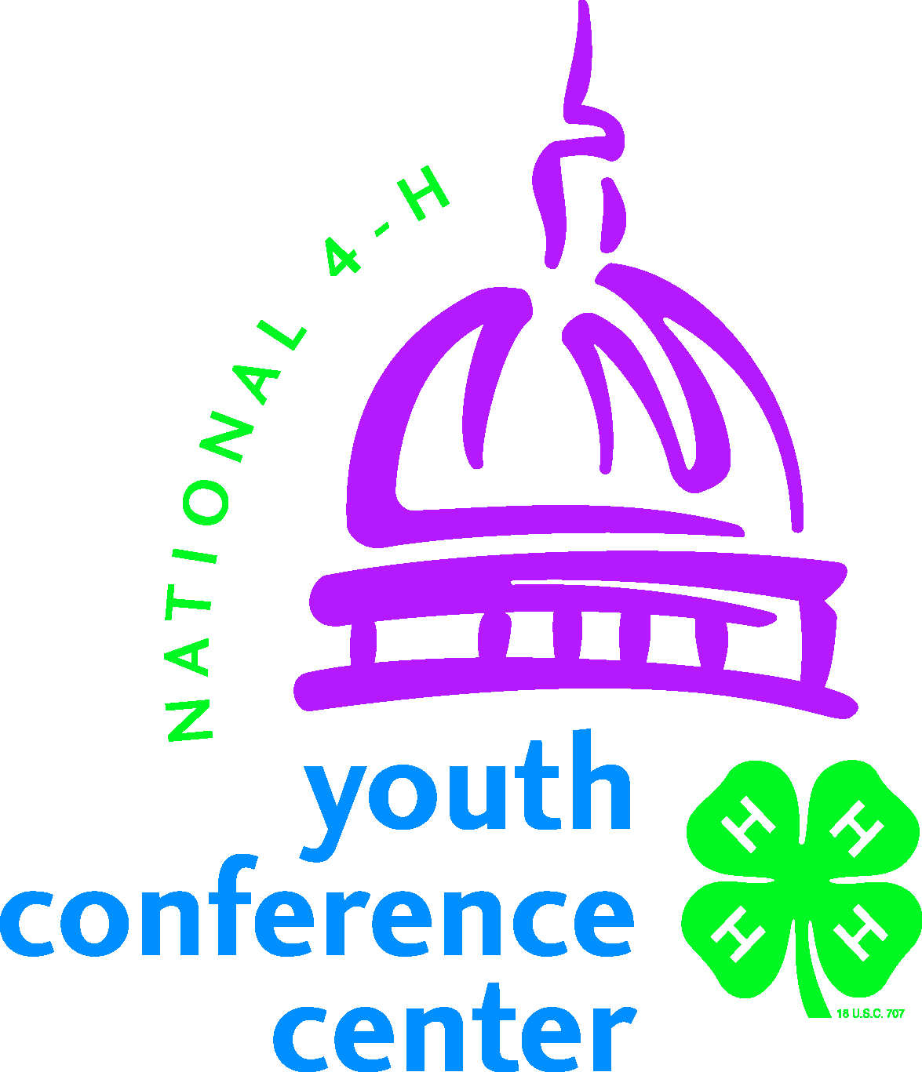
Media and Information Release

Participant Name: ___________________________________________________________________________

I give to the National 4-H Youth Conference Center and National 4-H Council, unlimited permissions to copyright and use, publish, and republish for purposes of advertising, public relations, trade, or any other lawful use, information about me and reproductions of my likeness (photographic or otherwise) and my voice, whether or not related to any affiliation with 4-H, with or without my name. I hereby waive any right that I may have to inspect or approve the copy and/or finished product or products that may be used in connection therewith or the use to which it may be applied.

Participant’s Signature: ________________________________________ Date: _________________________

Consent of parent or legal guardian if above individual is a minor:

I consent and agree, individually and, as parent or legal guardian of the minor named above, to the foregoing terms and provisions. I hereby warrant that I am of full age and have every right to contract for the minor in the above regard. I state further that I have read the above information release and that I am fully familiar with the contents.

Name: ______________________________ Relationship: ______________________

Parent/Guardian’s Signature: ______________________ Date: _________________

Code of Conduct

Participant Name: ___________________________________________________________________________

I hereby agree to attend Citizenship Washington Focus, participate fully in all sessions and abide by the established rules.

Specific rules include, but may not necessarily be limited to the following:

- Quiet is to be observed in sleeping room areas after specified times each night. All participants are to be in their own rooms at such time. During other hours, boys and girls may not be in the same sleeping room.
- The use of alcohol, tobacco, or illegal drugs is not permitted.
- All participants shall show respect for the property and facilities used during this event and assume financial responsibility for any damages they cause.
- All participants are responsible for attending all scheduled activities during the event. Any unauthorized absence is not permitted.
- All participants should have respect and courtesy for programs and speakers in progress by remaining for the entire program and show courtesy when taking flash photos during speeches and entertainment.

If I break this agreement or my conduct is not satisfactory to the conference center staff, I understand that I can be sent home early and will be responsible for paying any costs incurred for this transportation. I also may be asked to return all funds expended on my behalf for my involvement in this event. I understand that I may not be eligible to participate in future activities of this sort, either at the national, state, or local level.

Participant’s Signature: ________________________________________________ Date: _________________

Parent/Guardian’s Signature: ___________________________________________ Date: _________________
Page 2
Health Information and Consent for Emergency Treatment Form

Participant Last Name: _______________________ First Name: ___________________

Emergency Contact Information (include parent or guardian):
Contact #1:

Name: _________________________________ Relationship: __________________

Address: _____________________________________________________________

City: ________________________ State: _______________ Zip: _______________

Home Phone: _____________ Work Phone: ____________ Cell Phone: __________

Contact #2:

Name: _________________________________ Relationship: __________________

Address: _____________________________________________________________

City: ________________________ State: _______________ Zip: _______________

Home Phone: ____________ Work Phone: _____________ Cell Phone: __________

In case of emergency, I (We) hereby authorize designated representatives of the Citizenship Washington Focus program to consent on my behalf to medical treatment and/or hospital care as advised and deemed necessary by emergency medical staff, physicians or surgeons. I (We) also understand that all financial obligations incurred, if not covered by insurance, will be my responsibility.

Additionally, I (We) have also read and noted that in case of emergency while attending Citizenship Washington Focus, participants may be contacted as follows:
Delegate’s Name
CWF Week 4/Michigan Delegation
c/o National 4-H Youth Conference Center
7100 Connecticut Avenue
Chevy Chase, MD 20815
Phone: (301) 961-2801.

I (We) agree that this participant can safely attend Citizenship Washington Focus.

Participant’s Signature: ____________________________ Date:_________________

Parent/Guardian’s Signature: _______________________ Date: _______________

Participant Name: _______________________________________________________
Date of last flu shot: _______________ Date of last tetanus booster: _____________

Please indicate “yes” or “no” for each of the following. If “yes” enter details indicating diagnosis, date of illness, name of hospital, length of hospitalization, name of doctor, and any other pertinent information.

Yes No
Nervous or Psychological
Problems such as epilepsy, emotional stress, convulsions, loss
of consciousness, dizziness, paralysis, frequent anxiety,
excessive crying. Please explain.
Lung Disease or Respiratory Problems
Asthma, blood spitting, persistent cough, tuberculosis,
abnormal chest x-rays.
Disease of Heart or Blood Vessels, increased or abnormal
blood pressure
Stomach or Intestinal Trouble Please explain.
Ulcers, gall bladder or liver disorder, jaundice, hernia, colitis

Arthritis, Diabetes, Kidney or Bladder Disease Please explain.

Hay Fever or Allergies Please explain.

Allergies to Medicines (including penicillin, tetanus) Please explain.

Impaired site or hearing, chronic ear infections

Recent surgical operations, accidents or injuries. Please explain.

Been a patient in a hospital (other than a recent
Surgical operation) Please explain.

Any infectious disease or contact within the past two months

Skin Disease

Allergy to Foods (please be sure to notify 4-H staff of special
dietary needs) Please explain.

Under on-going care of a physician for chronic or recurring
Problem- Explain

Currently taking medicines (list names and doses)

Please list any special assistance needed, such as dietary or accessibility restrictions:

Insurance Company | Policy Number
Phone: ( ) | Name on Policy
Family Physician or Clinic |  | Phone: ( )
Page 5
Citizenship Washington Focus
Participation Agreement

I, ___________________________, have read and understand the basic rules for participation in the CITIZENSHIP WASHINGTON FOCUS PROGRAM and agree to:

- Participate fully in all scheduled CWF activities.
- Be responsible for my own behavior and uphold high standards for the group.
- Abide by the Code of Conduct rules and responsibilities.
- Abide by the program's Dress Code.
- Leave The National 4-H Center facility in the same condition that I found it when I arrived.
- Support and abide by the Group Coordinator's and Adult Advisors' leadership of my delegation.
- Cooperate with National 4-H Center and CWF Program Staff.
- NOT use alcoholic beverages, illegal drugs, tobacco products, or fireworks while participating in the CWF Program.

Delegate's Signature ___________________________ Date _______________

Concurrence by Parent or Guardian:
I understand the above agreement and will support my son/daughter, the CWF staff, and Adult Advisors in adhering to the CWF Code of Conduct and Dress Code. In the event that my son/daughter has to be sent home for illness or does not follow the policies, I understand the following:
- I will be contacted by the Michigan 4-H Youth Development site coordinator that my child is being sent home.
- I am responsible for the travel costs including airfare and ground transportation from National 4-H Council and the airport.
- It is my responsibility to make travel arrangements and communicate those arrangements with the Michigan 4-H Youth Development site coordinator or their designee.
- The Michigan 4-H Youth Development site coordinator or their designee will deliver the child directly to the gate of the departing flight.
- Michigan State University Extension, 4-H Youth Development will have no liability for anything that occurs after that time.

Parent/Guardian's Signature ________________________ Date ____________

MSU is an affirmative-action, equal-opportunity employer. Michigan State University Extension programs and materials are open to all without regard to race, color, national origin, gender, gender identity, religion, age, height, weight, disability, political beliefs, sexual orientation, marital status, family status, or veteran status.
4-H Overnight Housing Parent/Guardian Permission Form
Parent/Guardian: Please complete the following information and return the top portion of this sheet to name/address of 4-H staff member by date. Keep the information at the bottom of this form for your records.

I understand that my child ___________________________________ will be attending

(name of child)

the Michigan 4-H Citizenship Washington Focus Trip on June 24 (Gettysburg) and June 25 – July 1, 2017 at the National 4-H Conference Center 7100 Connecticut Ave. Chevy Chase, Maryland 20815,

and that he or she may be sharing lodging with an unrelated adult (21 or older) who has been through the Michigan State University Extension Child Well-Being Volunteer Selection Process* and with at least one other youth. By signing this form I give my permission for my child to attend this event under these lodging conditions. I also understand the Michigan 4-H Code of Conduct** expectations for adults and youth attending this event.

________________________________________ _____________________
Signature of Parent/Guardian Date


Parent/Guardian: Keep this information for your records:

Name of event: Michigan 4-H Citizenship Washington Focus

Date of event: June 24-July 1, 2017

Location of event: National 4-H Conference Center 7100 Connecticut Ave. Chevy Chase, Maryland 20815 (June 24 - Gettysburg)

In case of an emergency requiring you to contact your child during the event, contact:

Trip coordinator: _________________________________________ Cell: ___________________________

*For more information on the Michigan State University Extension Volunteer Selection Process, contact your local 4-H staff member or go to http://web1.msue.msu.edu/msue/cyf/youth/cwbvsp.html

**Michigan 4-H Code of Conduct for 4-H Activities: Positive behavior is a key expectation for youth and adults participating in 4-H activities – behavior that reflects trustworthiness, respect, responsibility, fairness, caring and citizenship. Participants are expected to follow all workshop and event guidelines. Theft, vandalism, the use of illegal drugs and alcohol, inappropriate or threatening behavior that violates the rights of others, and other such offenses are strictly prohibited, and anyone involved with these offenses will immediately be sent home at his or her own expense. If it is determined by 4-H staff or persons in charge of the activity that the offense warrants it, the offender will be turned over to the proper authorities.

